

TASCO Motor Insurance Growth Platform · TGP-DEL-02
Delivery Methodology
Date – 07 October 2026
Version – 1.0
Prepared by – iorta TechNXT
TABLE OF CONTENTS
1. Document Control 3
2. Acronyms 3
3. Introduction 4
4. Approach 4
5. Lanes of change 4
6. Sprint cadence 5
6.1. Roles 5
6.2. Ceremonies 5
7. Definition of ready 6
8. Definition of done 6
9. Quality gates 7
10. Environments 7
11. Governance 8
11.1. Forums 8
11.2. Change control 9
11.3. Escalation 10
12. Reporting 10
13. Tooling 10
14. Sign-Off 11

Document Control

Date | Version | Author & Business Unit Info | Reviewed By & Business Unit Info | Approved By & Business Unit Info | Change History
07/10/2026 | 1.0 | iorta TechNXT  Delivery Management | TASCO Insurance  Programme Management | TASCO Insurance  Programme Sponsor | Initial issue for submission

Acronyms

Acronym / Symbol | Definition / Meaning
API | Application Programming Interface
CI | Continuous Integration
DAST | Dynamic Application Security Testing
IT | Information Technology
MFA | Multi-Factor Authentication
MVP | Minimum Viable Product
QA | Quality Assurance
RACI | Responsible, Accountable, Consulted, Informed
RAG | Red, Amber, Green status
SAST | Static Application Security Testing
SIT | System Integration Testing
SME | Subject-Matter Expert
TNDS | Compulsory motor third-party liability insurance (Bảo hiểm TNDS bắt buộc)
UAT | User Acceptance Testing
UI | User Interface
UX | User Experience
VETC | VETC Automatic Toll Collection Company

Introduction
This document describes how iorta TechNXT runs the delivery of the TASCO Growth Platform (the platform): the sprint cadence, the definitions of ready and done, the quality gates, the environments, and the governance forums through which TASCO Insurance and VETC steer the work.
It applies to the MVP described in TGP-DEL-01 Project Plan, from discovery to the end of hypercare, and to releases made during the pilot.
The audience is the TASCO product owner, the delivery team, TASCO IT and the members of the steering committee and product council.
Related documents:
ID | Title | Relationship
TGP-DEL-01 | Project Plan | Stages, sprints and milestones
TGP-DEL-03 | RACI Matrix | Roles for each activity
TGP-DEL-04 | Risk Register | Risks reviewed in the forums below
TGP-QA-01 | Test Strategy | Test levels and coverage targets
TGP-OPS-06 | Release and Change Management | Production release process
TGP-ARC-07 | Architecture Decision Records | Where design decisions are recorded

Approach
We run two-week sprints for the build and use the contract milestones M1 to M4 as stage gates. Each sprint ends with a working demonstration on the integration sandboxes, so TASCO sees progress every two weeks.
Some changes cannot simply be iterated into production in an insurance business: premiums for TNDS, customer wording, consent, contact rules, partner commission, security and personal data. For these, the platform enforces approval by a named second person before the change takes effect, and the approval is kept in the audit trail.
Most business behaviour lives in rule sets, not in code. Scoring weights, journey timings, message wording and benefits are configured with TASCO’s product team in the rules studio during the sprints, rather than specified on paper and handed over.

Lanes of change
Every change reaches production through one of three lanes.
Lane | Examples | Path to production | Approver
Code | New adapter, defect fix, screen change | Pull request, CI quality gates, pre-production, release | Peer reviewer; TASCO change advisory board for production
Security configuration | Roles and permissions, MFA settings, secrets | Pull request with security review, then release | TASCO IT security
Business rules | Scoring, journeys, benefits, message templates, voice script, commission, contact rules | Rules studio: draft, check, simulate, submit, approve | A different user with approval rights; compliance officer for restricted rule types
The platform refuses self-approval of a rule change. Contact rules, wording controls, access policies, commission and retention can only be approved by a compliance officer. Product changes from TASCO core arrive through the catalogue sync at 01:00 Vietnam time as a proposed change and go through the same approval. In production, the price a customer pays is set by TASCO core.

Sprint cadence

Roles
Role | Held by | Responsibility
Product owner | TASCO | Owns the backlog, sets priorities, accepts stories
Engagement manager | iorta TechNXT | Runs the delivery, removes impediments, reports status
Business analyst and insurance SME | iorta TechNXT | Writes stories and acceptance criteria; configures rules with TASCO
Delivery team | iorta TechNXT | Architecture, integration, engineering, QA, DevSecOps, UX
Client experts | TASCO and VETC | Attend refinement and reviews: core system, VETC integration, compliance, telesales

Ceremonies
Ceremony | When | Length | Participants | Output
Sprint planning | First day of sprint | 2 hours | Delivery team, product owner | Sprint goal and committed stories
Daily stand-up | Daily, 09:15 Vietnam time | 15 minutes | Delivery team | Impediments raised
Backlog refinement | Weekly | 90 minutes | Product owner, analyst, architect, QA | Stories that meet the definition of ready
Integration sync | Twice a week | 30 minutes | Integration lead, TASCO IT, VETC integration lead | Interface questions and sandbox issues resolved
Rules workshop | Weekly | 60 minutes | Analyst, TASCO product team, compliance | Rule changes drafted and simulated
Sprint review | Last day of sprint | 90 minutes | Product owner, key users, delivery team | Increment demonstrated against acceptance criteria
Retrospective | Last day of sprint | 60 minutes | Delivery team | Two or three improvement actions
During hypercare and the pilot, releases move to a weekly cadence outside the Tết change freeze.

Definition of ready
A story enters a sprint when:
- It names the user role and the screen or interface it affects.
- Its acceptance criteria are written as Given/When/Then scenarios, including at least one failure case (permission refused, invalid input or rule violated).
- The permission it needs is identified. Any change to roles and permissions is flagged for security review.
- The design is approved, or marked “no screen change”, with Vietnamese and English text supplied.
- The personal data it touches is identified, with its masking rule.
- Any integration it depends on has an agreed specification or a simulated adapter.
- Any regulated element has a named approver (compliance, underwriting or legal).
- It is estimated and fits in one sprint.

Definition of done
A story is done when every applicable item is met.
Criterion | How it is checked
Code reviewed and merged by someone other than the author | Branch protection
Lint clean | npm run lint in CI
Automated tests written and passing, including one functional test per acceptance scenario | npm test
Coverage at least 80% of lines and functions and 70% of branches | npm run test:coverage
No new critical or high security findings | Security tests, SAST, dependency audit, secret scan
Permission tested: the allowed role succeeds, others are refused | API tests
Accessibility: no serious automated findings; keyboard walkthrough on changed screens | QA checklist from TGP-UX-02 UX Standards and Accessibility
Vietnamese and English text present; dates as DD/MM/YYYY; amounts in VND | UI review
Audit event recorded for every change affecting customers, money, access or rules | Test asserts the audit entry
API specification regenerated if routes changed | OpenAPI job
User documentation and runbooks updated | Pull request checklist
Accepted by the product owner at the sprint review | Story status
A rule change is done when it passes the platform’s checks, simulation results on representative customers are attached to the change request for scoring, journeys, next best action and benefits, a different user has approved it, and the expected effect is monitored for seven days after activation. Rollback creates a new draft that also needs approval.
Today the platform has 255 automated tests (252 pass, 3 to-do for manual or roadmap scenarios), with 99.41% line, 88.25% branch and 97.12% function coverage. A separate suite of 8 tests runs against PostgreSQL.

Quality gates
Gate | Where | Pass criteria | Blocks
Pull request | CI | All tests, coverage thresholds, dependency audit, secret scan, SAST | Merge
Integration | SIT, nightly | Contract tests against TASCO core and VETC sandboxes; PostgreSQL suite | Release candidate
Release candidate | Pre-production | Regression, DAST, performance, accessibility, API change review | Production release
Production | TASCO change advisory board | Release notes, rollback plan, runbooks updated, on-call confirmed, outside the change freeze | Deployment
Milestone | Steering committee | Evidence for M1 to M4 in TGP-DEL-01 Project Plan | Next stage and payment
Each sprint report tracks escaped defects, coverage trend, open security findings by severity and age, and open accessibility issues.

Environments
Releases move through four environments, as in the proposal, section 13.2. The diagram shows the promotion path.
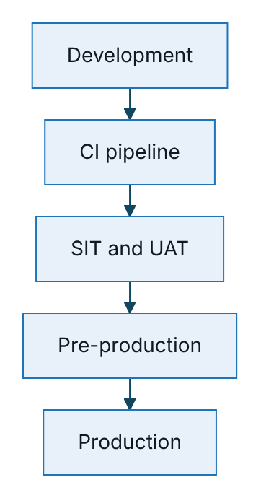
Figure 1 – Promotion path through the four environments
Environment | Purpose | Data | Demo mode
Development | Daily engineering | Synthetic only | On
SIT and UAT | Integration with TASCO and VETC sandboxes; user acceptance; training | Synthetic or masked | On in UAT only, for named demo accounts
Pre-production | Performance and security testing, release rehearsal | Masked | Off
Production | Live service | Real, encrypted | Off
The hosted UAT used for the proposal walk-through already runs on PostgreSQL. UAT credentials are issued in the access workbook and are never written in documents. Production refuses to start without a database connection, refuses demo mode, and refuses local rating unless TASCO approves it explicitly. Rule sets are promoted through the rules studio in each environment, not by copying databases. Production data is never copied to a lower environment unmasked.

Governance

Forums
The governance forums are those in the proposal, section 22. The diagram shows how decisions flow from the steering committee to the delivery team; feedback from each sprint review goes back to the product council.
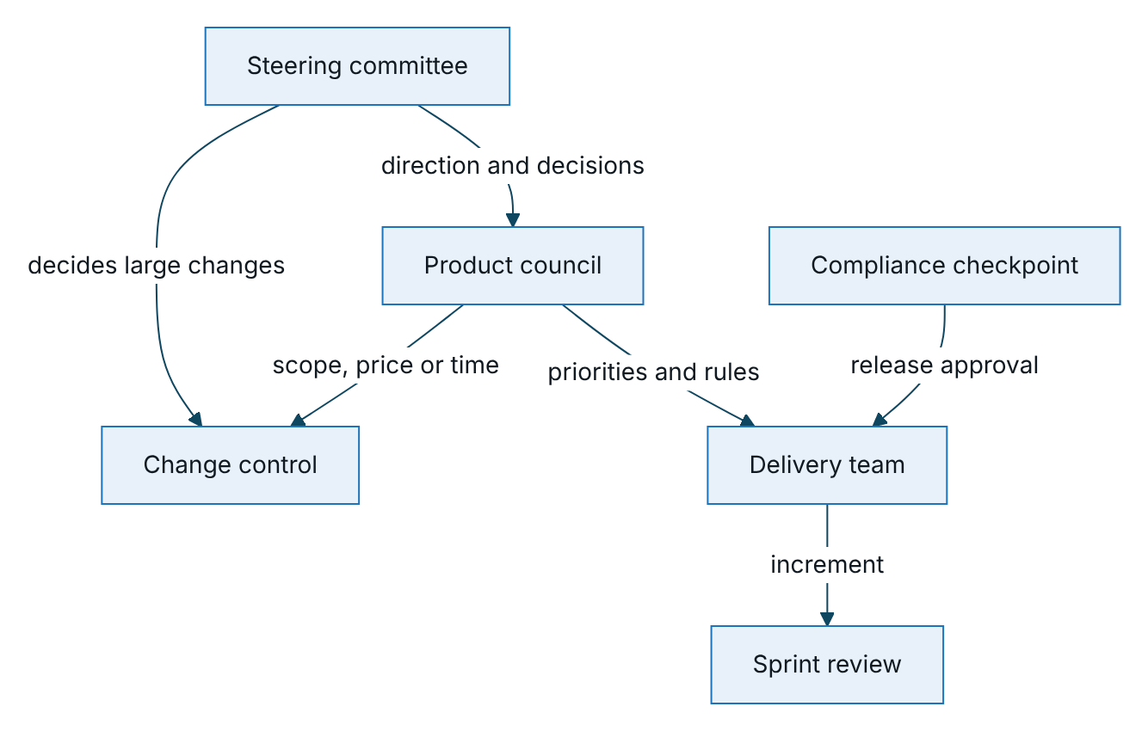
Figure 2 – Governance forums and how decisions flow to the delivery team
Forum | How often | Who attends | Purpose
Steering committee | Monthly, and at each milestone | TASCO and VETC sponsors, iorta TechNXT engagement manager | Direction, budget, milestones, risks, pilot results
Product council | Every two weeks | TASCO product owner, VETC lead, iorta TechNXT analyst and architect | Priorities, rule changes, scope decisions
Sprint review | Every two weeks | Product owner and key users | Demonstration against acceptance criteria
Change control | As needed | Product owner and engagement manager | Assess and approve changes to scope, price or time
Compliance checkpoint | Each release | TASCO compliance | Customer wording, consent, privacy, audit evidence
Production releases also pass TASCO’s change advisory board, as described in TGP-OPS-06 Release and Change Management. Architecture decisions are recorded in TGP-ARC-07 Architecture Decision Records and reviewed with TASCO IT in the integration sync.

Change control
A change request states the change, the reason, the effect on scope, price and time, and the proposed funding. The engagement manager assesses it within five business days. The product owner and engagement manager decide on it in change control. The USD 5,200 change reserve is held by TASCO and is used only with TASCO’s approval; a change that exceeds the reserve or moves a milestone goes to the steering committee. Approved changes are priced at the rate card in TGP-BUS-07 Commercials and Engagement Model.

Escalation
Level | Who | Time to respond
1 | Engagement manager and TASCO product owner | One business day
2 | Product council | Next session, or within three business days
3 | Steering committee | Next session, or an extraordinary session for red items

Reporting
Report | Audience | Frequency | Content
Status report | Product owner, steering committee members | Weekly, Friday | RAG status, milestone forecast, top risks and issues, decisions needed
Sprint report | Product owner, product council | Each sprint | Sprint goal met or not, scope change, quality measures
Steering pack | Steering committee | Monthly | Milestones, budget and change reserve, risk summary, pilot measures
Pilot report | Steering committee | Weekly digest during the pilot; full report at the read-out | Pilot measures against targets and the control group
Green means on track. Amber means at risk, with a recovery plan owned by the responsible lead. Red means a milestone will be missed without a steering committee decision.

Tooling
Purpose | Tool
Backlog and sprints | Jira or Azure Boards, or the TASCO standard
Source code and CI | Git repository with branch protection; CI pipeline running lint, tests, coverage and security checks
Test management | Test-case workbook (TGP-QA-02 Test Case Catalogue), handed over at acceptance
Documentation | Word documents listed in TGP-00 Document Register
Monitoring | Prometheus metrics, structured logs, alerting, as in TGP-OPS-02 Monitoring and Alerting

Sign-Off
Serial Number | Description | Owner | Status
1 | Backlog and test management tools (TASCO standard or iorta TechNXT default) agreed in discovery | TASCO IT | Open
2 | Release path to production through the TASCO change advisory board agreed | TASCO IT | Open

Sign Off Date | Signature | Approved By | Department & Project Role
 |  | TASCO Insurance | Programme Sponsor
 |  | TASCO Insurance | Programme Management
 |  | iorta TechNXT | Delivery Management



